SCHOOL BOARD ROLES & RESPONSIBILITIES
The Bateman Primary School Board’s main role is to be involved in the governance of the school, which means playing a role in shaping and monitoring the school’s objectives, priorities and general directions. It is not the Board’s role to manage the school – that is the Principal’s responsibility. The main differences between School Councils and School Boards are that:
- the Board signs off on a Delivery and Performance Agreement (which is a binding agreement between the Department of Education (Director General), the School (Principal) and the School Board (Chair) that places specific performance and
- accountability expectations upon schools; and
- Boards take part in the DES independent review at the end of the three year DPA cycle.

The Board participates in:
- formulating, endorsing and annually reviewing the school’s Business Plan;
- processes to review school performance;
- processes to determine satisfaction levels of parents, staff and students; and
- endorsing the school’s annual report.

A School Board can have between 5 and 15 members. Members are elected for a maximum of three years, but can be reappointed more than once. Parents are elected by parents. Staff are elected by staff.
MEMBERSHIP
Chris Speijers (Chairperson)
As a former student, I had no hesitation in sending my own children (from out of area) to Bateman PS. I have sat on both the School Council (2014-2017) and the School Board (2018-present), including taking on the Chairperson role this year. It has been great to see the positive changes implemented at Bateman these past few years and I look forward to continuing the improvements in 2019. With 2 children now progressed to High School, my time and involvement at Bateman will come to an end in 2020 when Henry graduates.
Jennifer Beauchamp (Deputy Chairperson)  I am the very proud mum of two children at Bateman Primary School. Ethan is in Year 6 and Nieve is in year 4. I have always tried to support the school both as a P&C member and as a member of the community. I run the Scholastic Book Club and Entertainment Book programs for the school. I love the community feeling of Bateman Primary and I’m looking forward to helping the school further its endeavours and achieve its strategic direction. | Picture Not Avaliable
Marc Lockett (Principal)  I was appointed as Principal of Bateman Primary for the start of the 2011 school year, our 8th Principal in just three years! In my time at Bateman I have witnessed our community and school become far more connected, great improvements in the way we teach and corresponding increased performance in tests such as NAPLAN, improved grounds and play equipment and exciting projects like the kitchen garden. I love the Bateman community and working with our excellent students and staff and I am excited about the future of our school. | 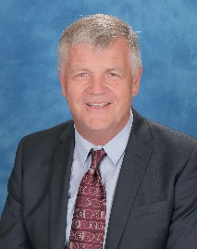
Cath Parry (Deputy Principal & Secretary)  I am an experienced educator and have worked in a variety of contexts in both the metropolitan area and in the country. I am the Deputy Principal and have a number of roles around the school. I enjoy seeing the students have their ‘lightbulb moments’. It is an honour to be on the School Board and to be overseeing the governance of the school. | Picture Not Available

PARENT REPRESENTATIVES
Marny Marsh  My children have been attending Bateman Primary School (BPS) since 2014. They are now in Years 3 and 6. I have been a member of the Council/Board since 2016, during which we have worked hard to introduce positive changes to the school, including the introduction of onsite before/after school and vacation care. We have a great school community and I look forward to continuing to work with the Board in 2019. | 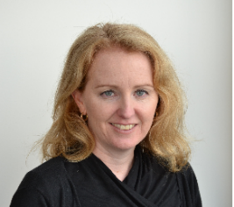
Natalie Walchshofer:
I have been a Bateman Primary parent for 7 years now. I have 3 children at Bateman (PP, Y3 & Y5). This is my second year on the school board. I love our little school and want it to be the best that it can be. I am here to assist the school in achieving the best possible outcome for all its staff and students. I am also secretary of the Bateman Netball Club and event co-ordinator for our P&C.
Stephan Dickinson
We have been at Bateman Primary School since 2012 when arriving in Perth. The Principal (Marc) was most welcoming to our family and had no issues with taking our son (Sam) into Pre-Primary at that time, which was one of our main reasons for setting down roots in Bateman. Since then we have seen the school go from strength to strength and whilst Sam has now moved on to senior school our daughter (Summer), in 2019, has started Year 2. With a few more years at the school I am looking forward to assisting with its future goals.
Kaye Few  I have 4 biological children raging in ages from 34 – 40 years old, I also have Special Guardianship of 3 Aboriginal children from the Kimberley region aged 13,11 and 10, all have been with me since birth. My son Colin is 11 and commenced schooling at Bateman in the last term of 2018. He is now in year 6 this year. I work as an Education Support Teacher at Corpus Christi Secondary College and enjoy working in the Ed Support Centre. Whilst new to the school, I have taken on the role of secretary of the P&C in 2019 and look forward to a bumper year. | 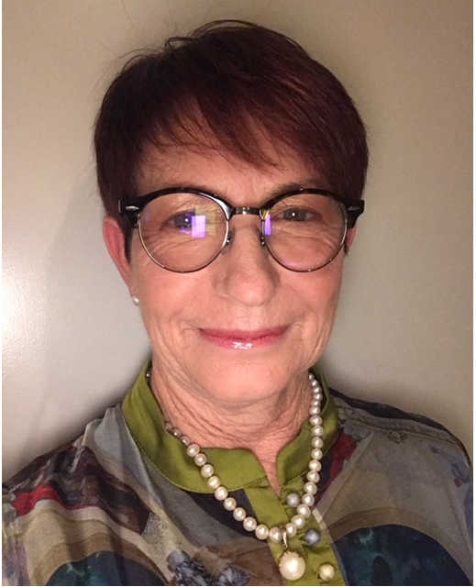
Terry Young  My two children have attended Bateman P.S. since kindergarten. I have been working in the education sector for 25 years and am currently employed by the Department of Education. I am passionate about education and every student having the opportunity to reach their full potential. I am excited to be on the BPS Board and look forward to working with the whole school community to continually improve our beautiful school. | Picture Not Available

TEACHER REPRESENTATIVES
Elle Bray:  I’ve been a teacher at Bateman Primary School since 2012. Prior to my time at Bateman, I was a member of the School Council of my last school in rural Western Australia. I am looking forward to working with the board to make positive changes to the school and wider community, particularly in the areas of Early Childhood and English. | 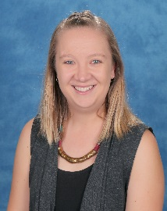
Callum Shepherd: 2019 is my third year as a fulltime teacher at Bateman Primary School. I graduated from Notre Dame university in July of 2016 and was lucky enough to be offered relief work at Bateman for Term 4 of that year. I am passionate about student health and wellbeing and well as technology integration across all learning areas. It is exciting to be a part of the Bateman School Board and having the opportunity to not only learn from colleagues and parents, but be able to share my thoughts and opinions on important school matters. | Picture Not Avaliable
Bateman Primary School, Bartling Crescent, Bateman WA 6150
T: 08 6258 6900 F: 08 9310 8801 E: bateman.ps@education.wa.edu.au www.batemanps.wa.edu.au

