SCHOOL BOARD ROLES & RESPONSIBILITIES
The Bateman Primary School Board’s main role is to be involved in the governance of the school, which means playing a role in shaping and monitoring the school’s objectives, priorities and general directions. It is not the Board’s role to manage the school – that is the Principal’s responsibility. The main differences between School Councils and School Boards are that:
- the Board signs off on a Delivery and Performance Agreement (which is a binding agreement between the Department of Education (Director General), the School (Principal) and the School Board (Chair) that places specific performance and
- accountability expectations upon schools; and
- Boards take part in the DES independent review at the end of the three year DPA cycle.

The Board participates in:
- formulating, endorsing and annually reviewing the school’s Business Plan;
- processes to review school performance;
- processes to determine satisfaction levels of parents, staff and students; and
- endorsing the school’s annual report.

A School Board can have between 5 and 15 members. Members are elected for a maximum of three years, but can be reappointed more than once. Parents are elected by parents. Staff are elected by staff.
MEMBERSHIP
Natalie Walchshofer (Chairperson)  I have been a Bateman Primary parent for 9 years now. I have 3 children, 2 of whom are at BPS (Year 2 & 5). My oldest is now in Year 7 at Melville High School. This is my fourth year on the school board and first year as the Chairperson. Professionally, I am the Project Officer at Zonta House Refuge Association, supporting our CEO and management team in the implementation of all our programs and service offerings. I also sit on the Strategic Sub-committee of the Zonta House Board.  I believe that schools should always be student centred. Student-centred schools focus on designing learning experiences that recognise and respond to the individual needs of each of their students. My role as the Chair is to work alongside the school and the community to ensure that that our school continues to drive and maintain not only a student led but community driven approach in all its workings.  I look forward to working alongside the school to achieve its strategic commitments in 2021. | 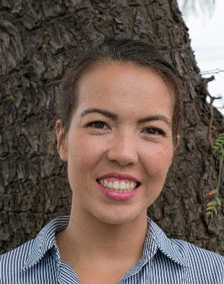
Marny Marsh (Deputy Chariperson)  My children have been attending Bateman Primary School since 2014 (my daughter has now graduated, but my son is in year 5). I have had the privilege of being a member of the Council/Board since 2016 and have seen a number of improvements implemented in the school during that time (not least becoming an Independent Public School and the introduction of before/after school and vacation care on site). We have a great school community and I look forward to continuing to work with the Board in 2021. | 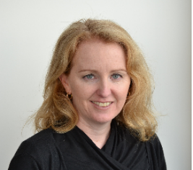
Marc Lockett (Principal)  I was appointed as Principal of Bateman Primary for the start of the 2011 school year, our 8th Principal in just three years! In my time at Bateman I have witnessed our community and school become far more connected, great improvements in the way we teach and corresponding increased performance in tests such as NAPLAN, improved grounds and play equipment and exciting projects like the kitchen garden. I love the Bateman community and working with our excellent students and staff and I am excited about the future of our school. | 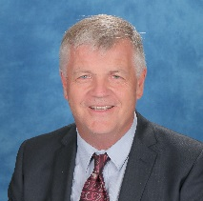
Cath Parry (Deputy Principal)  I am an experienced educator and have worked in a variety of contexts in both the metropolitan area and in the country. I am the Deputy Principal and have a number of roles around the school. I enjoy seeing the students have their ‘lightbulb moments’. It is an honour to be on the School Board and to be overseeing the governance of the school. | 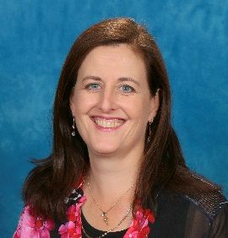
Sonja Katnich (Deputy Principal)  Across twenty plus years I have had a passion for teaching and the privilege to teach every year level, while keeping in mind the role of a school in a child’s life. I believe through creating a secure environment and connecting with students they can always achieve more than they believe they are capable of, nothing is more rewarding for me than sharing in a child’s success. It has been an absolute pleasure working at Bateman Primary for the past six years, a school that embraces and supports all aspects of a child. As the Student Services and Early Childhood Deputy Principal my purpose is to work collaboratively with and to support the students, staff, families and community to build a strategic whole school approach to health and wellbeing creating a learning environment where all students thrive, knowing they are safe and happy. | 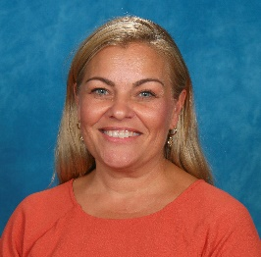

PARENT REPRESENTATIVES
Louise Liu:  Hello, my name is Louise Liu and I have nominated for a position on the school board.  I am married with one daughter who is currently year 2 at Bateman Primary School. My family have lived in Bateman since 2009 and absolutely love our little tight community. You probably see us with our fluffy ball dog Shadow at the park every night.  I am a qualified CPA and working as a manager in the state government. I have years of experience in change management, project management, applying and implementing government legislations and working with people from all walks of life.  I worked on the Chung Wah Chinese Leeming School Board for the past 2 years and gathered valuable experience on the functions and the importance of school board. I am proficient in Mandarin and believe that my skills will be useful for our school Chinese program.  I want to play an active role in the management of our primary school community. I am a strong believer in acting with respect, honesty and open communication, and I want all our children to learn in a safe environment without harassment and bullying. I look forward the opportunity to be part of our school board and work closely with school management and P&C. | 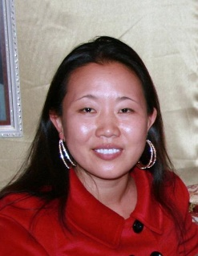
Krista Harris:  My name is Krista Harris. I am the parent of three children, one in his first year of high school (Joshua) and two who are currently attending Bateman Primary School (Will Yr5, Lachlan Yr4). I have been part of the Bateman Community for 9 years, with all three children having attended from kindergarten. I have a good understanding of issues arising from the early years of education, through to matters impacting our older students.  I am currently employed as an Executive Assistant to a Barrister, operating at Francis Burt Chambers. I have worked at various legal firms around Australia for 18 years, of which the last seven years have been at Francis Burt Chambers.  Working in a legal environment, I have a careful eye for detail. I understand the importance of generating correct, fact-checked material, and working to deadline. This  is a work ethos I carry across the board, whether generating internal content, or creating opinion material that will be produced to a judge in our highest courts.  I am the Registrar at Rossmoyne Junior Football Club. I enjoy giving my time to ensure all children have the best Club and junior football sporting experience they can. Go Raiders! | 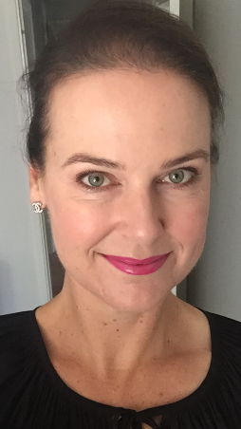
Felix Chan:  As an Associate Professor and Academic Lead, Discipline of Economics at the School of Accounting, Economics and Finance, I have been heavily involved in educating students for the past two decades across diverse fields of subjects including finance, economics, econometrics, data analytics and data science. This has provided me with firsthand knowledge and experience about the necessary things that an early childhood education requires to set students up for future success. This has been emphasised through my work as a university researcher, educator and administrator,  across my interactions with hundreds of students with diverse backgrounds, along with my practical and theoretical knowledge in educational techniques and methodology. Given these experiences, I understand that the education provided by Bateman Primary School will have long lasting impacts on our children’s development. This motivates me to join the School Board to represent the concerns of parents as we all share the same interests in having our children receiving a quality education. | 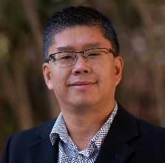
Dean Fearnall:  I have 3 children at Bateman Primary (Kindy, Y1, Y3) and this is my first year as a member of the school board. As a board member I will help the board work towards the community expectations and the school's priorities to reflect the needs of the students of the school.  Being on the school board means a lot to me and enables me to become involved in contributing to achieving the best outcomes for the students. I am looking forward to working with the other board members and school staff in working towards these goals. | b
Amy Henry:
Hello, my name is Amy Henry. I have been involved the community and education for many years and feel that I can bring a broad perspective and knowledge to the position. I am a parent to three vibrant Bateman Primary School children and have worked as a passionate Primary School educator for the past 18 years. My position as a teacher has given me the knowledge and skills that will be valuable as a board member. I have taught across many year levels, subject areas and interacted with people from all walks of life.
I have been a committed member of the Bateman Primary School P&C for three years and have played an integral part in fundraising and event organisation and a building a strong school community through events and programming. These include the annual school disco, Leaf fundraiser, colour run, ice cream Friday and most recently the 50th Anniversary Festival of Bateman. These events required a high level of organisation and leadership, good communication and interpersonal skills.
Outside of school the school community I also play an active role in a number of community groups such a team management for Manning Rippers Football club and Netball coaching.
I am proud member of the Bateman Primary school community and I will be committed to making our school exceptional for everyone in the community. I look forward to working with the school community to achieve the best outcome possible for all students and families.

Wendy Mobley:  Our family has been part of the Bateman community since 2010 when it was a very different place. Over the years I have witnessed the school grow and development with many positive changes. However, I believe it is important we continually look for ways to improve for the benefit of our students, staff and community whilst still maintaining that ‘Bateman feel’.  Currently my children are Year 10 at Rossmoyne SHS and Year 5 at Bateman PS. I am a School Officer at Como Secondary College. | Photo Unavailable

TEACHER REPRESENTATIVES
Elle Bray:  I’ve been a teacher at Bateman Primary School since 2012. Prior to my time at Bateman, I was a member of the School Council of my last school in rural Western Australia. I am looking forward to working with the board to make positive changes to the school and wider community, particularly in the areas of Early Childhood and English. | 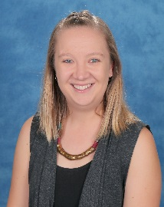
Jordan Block:  I have been a teacher at Bateman since 2016. It has been an incredible experience to be part of the growth of Bateman Primary School in the past five years. I am particularly interested in student wellbeing and have been a part of the Positive Schools Committee during this time. I have been part of the team that created the Wellness Days and other activities that supports students’ mental health. I also have a great wealth of knowledge about upper primary curriculum and needs and able to bring that to the Bateman School Board to ensure that they are considered in developing the school’s direction. | 