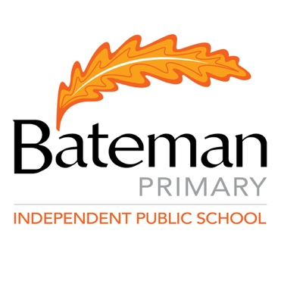

Bateman
Primary School

Photographing, Filming and Recording Guidelines

October 2019
PURPOSE
The aim of these guidelines is to:
- Advise parents/guardians when photographs and/or film are to be taken and how they will be stored and/or used.
- Control and manage how and when others collect and publish photographs and/or films of students.
- Provide guidelines for parents regarding photographing or filming their children participating in Bateman Primary School events or performances.
- Provide parents/guardians with the choice to withdraw consent for their child to be photographed or filmed.

Definition
‘Use’ relates to both images and film that are shared and distributed within the school for school purposes and images and film that may be shared and distributed outside of the school staff and are available for other students, parents/ guardians and the wider school community.

GUIDELINES

- There are many occasions during the school year where staff photograph or film students participating in school activities or events, for example: classroom activities, sports events, concerts, excursions, camps etc. Bateman Primary School do this for many reasons, including celebrating student achievement and participation, showcase particular learning programs, document student learning and experiences such as camp, excursions, sport events, communicate with parents/ guardians and wider school community through different mediums. All photos taken for school purposes will be stored on the school server.
- A consent form will be provided to families twice per the student’s time at Bateman Primary School giving general consent for their child’s photo to be used in publications such as, but not limited to, online and printed school newsletters, reports and other materials, school websites, P&C Facebook site, Department of Education of WA online and printed information printed external media such as newspapers, on the internet, or on film or video.
- Any time a child is having a photo or filming conducted by a third party for the use of the school website, media, brochures, or online, parents/guardians will be notified of the third party and how the photographs/filming will be used. Parents/guardians are able to withhold permission for their child to be photographed or filmed by the third party.
- Bateman Primary School will use student images reasonably, appropriately and sensitively, consistent with our obligations under Department of Education Intellectual Property Policy and Procedures Document. If at any time a parent/ guardian or student have concerns about the use of any images or film, they should contact the principal directly.
- It is the parent/guardian responsibility to notify the school if they wish to withhold consent for photos taken and used during a specific school approved activities.

Official school photographs

- Each year, Bateman Primary School will arrange for a professional photography company to take official school photographs of students. This will generally involve both whole class photos and individual photos being taken as well as year 6 graduation photos. Official school photos may be; purchased by parents/guardians, used for school/student identification purposes, stored on the school server.
- Bateman Primary School will notify parents/guardians prior to the official school photographs being taken to give them an opportunity to decide whether their child will be included in them.

School performances, sporting events and other school approved activities

- Bateman Primary School invites parents/guardians to photograph or film only their own child/ren during sporting events, performances such as assemblies, community songs, end of year concerts and other school approved activities.
- Parents/ guardians are not permitted to photograph or film any other student and upload to social media sites such as Facebook, Instagram etc at any type of school event or carnival.
- Parents/guardians will receive notification prior to school performances, sporting events and other school approved activities about the photography and filming guidelines.

Student use of personal devices

- Bateman Primary School students may have images or film of other students for work related purposes only. The student that has taken the photographs or video must have permission from the other student/s and the classroom teacher must be aware of the photographs or film been taken.
- Bateman Primary School students cannot upload images of other students to any sort of social media such as Facebook, Instagram, YouTube etc.
- Students will be required to delete any photos or video that involves any other student at the end of each school year.
- School shared iPads will be cleared of photos and video at the end of each school year.
- Refer to Bateman Primary Behaviour Management Policy if breaches of this aspect occur.

Staff use of personal devices

- Bateman Primary School staff may use their own personal devices to capture images of students for reasonable and legitimate educational purposes. If this occurs, staff are expected to upload the images to the school server and delete the images from their device within a week of the images being taken.

ENDORSED BY THE SCHOOL BOARD : October 2019

