Okonominyaki- Japanese Pancakes
Makes 8
Ingredients;
¼ large green cabbage, shredded
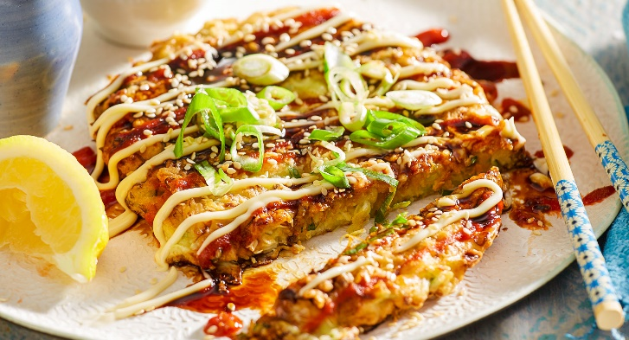
1 carrot, grated
½ large onion, finely slice
180g plain flour
6 eggs, whisked
To Serve
sweet soy sauce
pickled ginger
Diced Shallots
Mayonnaise, Kewpie

Method;

1. Peel outer leaves off cabbage then very finely slice and place into a large bowl.
2. Finely slice onions then add to cabbage.
3. Grate carrots and add to bowl.
4. In another large bowl place flour and mix in eggs then whisk until smooth. This should be a thick pancake consistency.
5. Mix all ingredients together.
6. Heat a non-stick fry pan then fry large spoonsful of mixture in olive oil. Don’t flip until golden brown.
7. Garnish with a teaspoon of mayo, a small pinch of pickled ginger, a drizzle of sweet soy and a pinch of dried shallots on top.

Happy eating

